**Remote Stove Controller**



**Mobile and IoT Computing Services, Spring 2018**

**Report**

**Paul Park**

**Rongpeng Zheng**

**Sihan You**

**Zhexi Liu**

# Acknowledgement

The Stove Remote Controller Team would like to appreciate Professor Norman for his guidance throughout the first half of the semester. We especially feel thankful for all the hints, questions and recommendations he brought to us during our bi-weekly office hour meetings. We would also like to express our gratitude towards folks who participated in our questionnaires and user experience surveys. We feel great sense of accomplishment with all the support, and we are looking forward for delivering the continuous development in the upcoming month.

**Acknowledgement 2**

**Summary 4**

Background & Motivations 5

User Personas 7

BUSINESS ANALYSIS 8

**SURVEY 9**

**BUSINESSES 12**

REVENUE MODEL 13

COMPETITOR ANALYSIS 14

**Overall Architecture 16**

Detailed Modules’ Description 17

(1) Mechanism structure: Stove, stepper motor and motor driver 17

(2) Microcontroller: Particle Photon 20

(3) Cloud service: Particle Cloud 21

(4) User side: user’s smartphone app 22

**Wireframe Prototypes 24**

1) Stove Tab 24

2) Schedule Tab 25

3) Recipe Tab 26

4) Log Tab 27

**Wireframe Prototypes Evaluation 28**

(1) Interview 1 28

(2) Interview 2 29

(3) Evaluation and Refinement 29

1) Stove Tab: 29

2) Log Tab: 30

3) Schedule Tab & Routine Tab 30

**What We Have Implemented 31**

(1) Software 32

(2) Hardware 33

**Security and Privacy Evaluation 34**

(1) Physical Safety 34

(2) Information Security 34

1. Data Transmission Security 34

2. Privacy 35

**Challenges, Limitation and Possible Solutions 36**

**Future Work 37**

(1) Some Other use cases 37

(2) Schedule of future work 38

**Job Break Down 39**

**GitHub repo 39**

**Reference 40**

**Appendix 41**

Poster 41

Survey Questions 42

Survey Response Statistics 44

Original Response 47

Hardware Specifications 50

# Summary

Remote Stove Controller (or Stove Guard) is an iOS application that enables remote control of stove devices over the internet. Our goal is to grant more flexibility to people who need to cook but also have to operate on tight clock schedule, or those who are simply tired to stand in the kitchen waiting for food to be ready. The Remote Stove Controller allows users to automate cooking routine, schedule tasks, and adjust heat levels all together from their iOS phone.

## Background & Motivations

Apart from the initial idea to automate cooking, our application is built with the intent to prevent home fire accidents caused by unattended stove tops. Being hustling college students ourselves, we are oftentimes worried about the safeness in our residential neighborhood (as some of us have witnessed fire incidents in real life). Our goal is to prevent forgetful individuals from burning down their houses, and we foresee the opportunity to generate both social and economical values in such device & application.

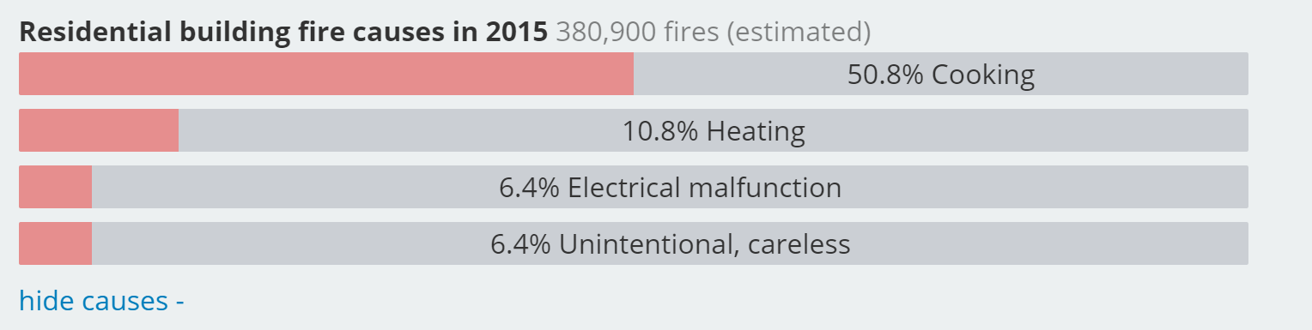

According to the report published by U.S Fire Administration [U.S fire statistics, 2015], a whopping amount of 50.8% of the residential fire incidents were caused by cooking,

higher than rest of all the other factors combined. This data also reflects an increasing trend in the number of cases cause by cooking fire since 2006 (moving towards 200 thousand by 2015).

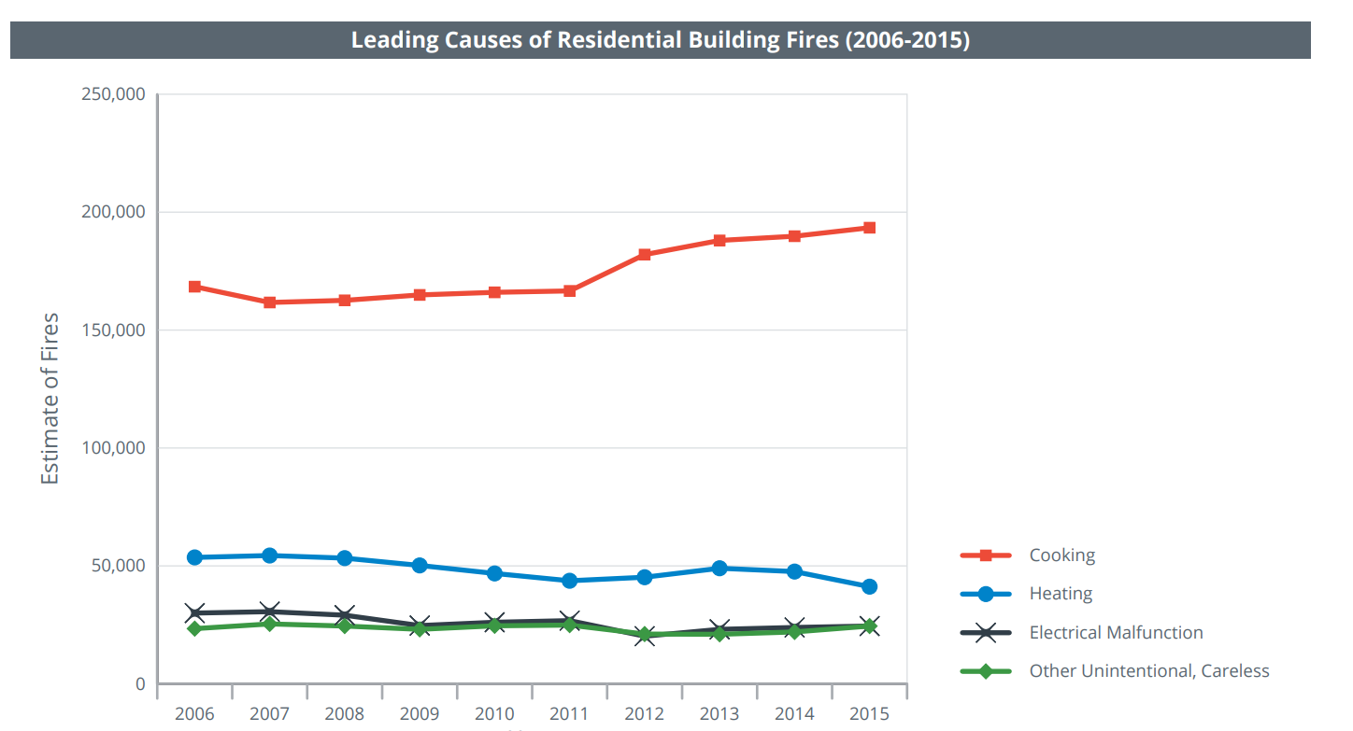

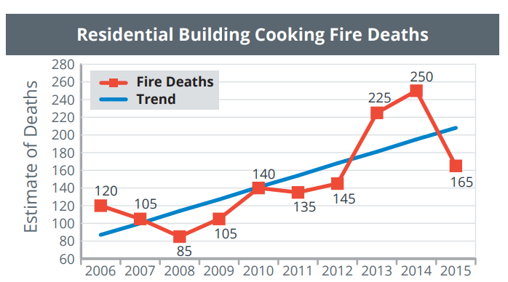

To demonstrate more details, the report also shows more devastating loss caused by residential cooking fire over the past 10-year-period:

1) 141% increase in deaths

2) 34% increase in injuries

3) 123% increase in dollar loss

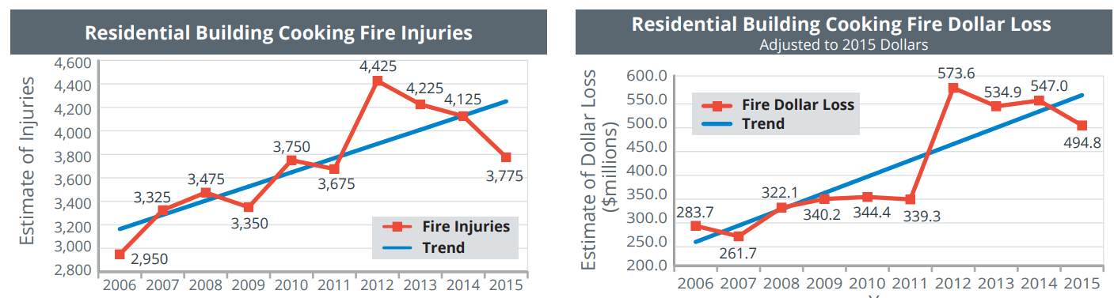

## User Personas

|  |  |  |
| --- | --- | --- |
| Group | | Use cases |
| College  Students | image39.png | Scheduling cooking tasks ahead of time and enjoy ready to eat meals. |
| Full-time parents | image99.png | Remotely adjusting stove levels while working on all the chores. |
| All the people who hates standing in the kitchen | image71.png | Automatic stove shut down with timer countdown.  Complete worry free! |
| Dining services/  group meal prepping | image91.png | Grocery stores, restaurants and hotels can use our switches to fully automate their food bars and soup stations. |

## BUSINESS ANALYSIS

Our initial project idea came from a team member’s bad personal experience with overcooking food and the obligation to constantly check if the stove is off after cooking.

We wanted to run a survey to ensure that these two issues exist and there is enough of a market to support our product. We also performed a competitive analysis to find out if there are any existing products that solve these problems. If so, we would adjust our product to deliver a unique value proposition to our target customers.

The market analysis targeted specific potential stakeholders of this product:

* Cooks (i.e. busy professionals/students).
* Businesses (i.e. restaurant owners, hotels)

For the cooks, we carried out a survey to understand the user behavior to solidify our assumptions and identify any unexpected constraints before we work on our system architecture. We also wanted to determine the potential market size of these customers as they would be our primary targets. For business owners, we turned to online research to understand their decision criteria when evaluating adoption of smart solutions.

# SURVEY

To understand whether there is a real demand for our product, we conducted an online survey with eight questions to determine the current habits while cooking.

Below are some key insights extracted from the survey results with 87 participants.

**1: Turning off stoves is easier said than done**

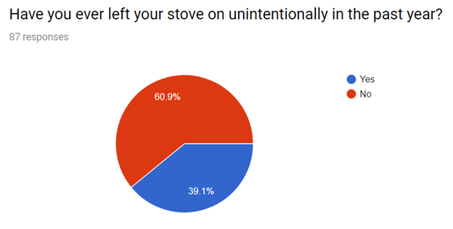

Nearly 40% of the survey respondents reported that they have left their stove on unintentionally within the past year.

The results of this survey down.

Fwejfioefwjiofwejio

**2: We are in an age where more people are cooking**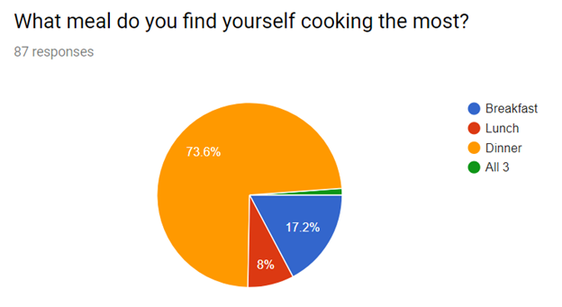

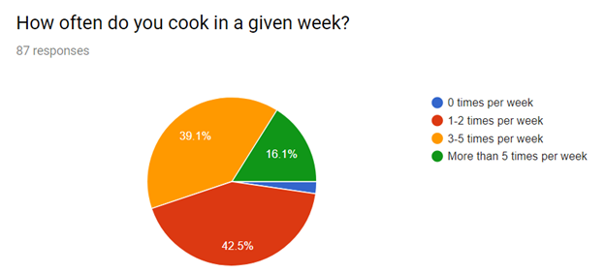

More than 70% of respondents cook dinner more so than any other meal. Only 8% responded that they cook lunch the most which is expected as we surveyed working professionals and students.

16% of survey respondents reported that they cook more than five times a week while over 80% of survey respondents reported that they cook anywhere from 1-5 times a week.

97.7% of respondents say they cook at least one time per week. The current working professional and student cooks a lot and when busy people cooking there are potential safety issues at hand. Our product looks to solve this issue and reduce risk before anything serious happens.

**3: There is a widespread issue of multitasking**

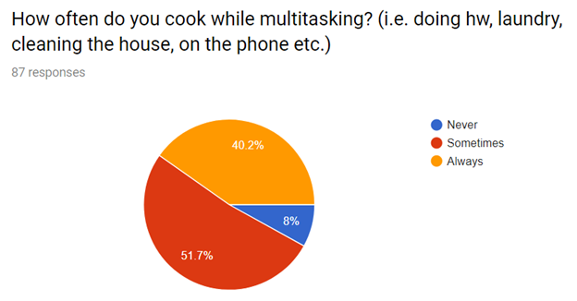

More than 90% of survey respondents reported that they multitask while cooking. This includes activities such as doing homework, laundry, cleaning the house, or on the phone.

In conclusion, the survey results align with our initial thoughts on overcooking food and forgetfulness. In a world where more and more people are cooking, and multitasking is becoming a normal occurrence, the risk for overcooking and leaving a stove on increases and our product aims to solve this problem and ultimately promote a better user experience.

# BUSINESSES

Since we have covered B2C market potential, we decided to investigate B2B options. We feel that our product has a place in businesses such as restaurants, grocery stores, and even hotels and other types of leased living. For these reasons, we conducted research to find the appropriate business model.

What Stove Guard Can Bring to Businesses?

Again, there are two aspects to our product:

1. Adding an additional safety tool
2. Automate cooking

Stove Guard enables users to control their stove remotely and create various schedules for different recipes. This could prove to be useful in a restaurant or the ready-made section of grocery stores where cooking schedules are usually consistent day-to-day. As a result, these business types could potentially reduce the number of staffed cooks and ultimately reduce costs. In addition, there is a safety aspect embedded in our product. Restaurants could potentially reduce their insurance bill if our product is recognized as an added safety measure.

During our research, one of the major concerns escalated from a business perspective is the reliance on technology could potentially be dangerous if there were any malfunctions with our product. Therefore, we added limitations on the business focused product. These Stove Guards would have to have limits on increasing heat and would need sensors for things like smoke or over-boiling or even an auto shutoff function when disconnected from the smartphone.

All in all, we explored this option minimally because we feel our true market, based on our market research, lies with the B2C market.

## REVENUE MODEL

With a comprehensive understanding of our target user and the benefits behind our solution, we designed a revenue model with easy monetization pathways for Stove Guard.

**1: Selling online direct to consumer.**

The prototype of our product cost about $50 total. Once we launch and finalize the product we estimate we can reduce this price to around $15. At a $199 starting price for four smart knobs we believe we can scale the business to further develop the product for future iterations but also at the same time we are offering peace of mind and a better user experience for an affordable price. Of course, the software application comes with the unit for free.

**2: Selling to retail stores**

With the same pricing structure and cost above, we would wholesale our product at $120 which offers retail stores and ourselves large margins with a suggested retail price of $199.

**3: Establishing an in-app market of pre-set schedules and recipes**

One of the main features of this product is automating the cooking process where the user needs to create schedules to their favorite foods to cook. However, not everyone wants to customize their own schedules. We can create an in-app market where we post pre-set schedules for common foods to cook such as eggs, soup, and many more.

## COMPETITOR ANALYSIS

We have conducted market research trying to find similar products. We have found one product that accomplishes one aspect of our product, the ability to remotely shut off your stove.

**INIRV**

Inirv provides a stove dial and a sensor placed on the ceiling like a smoke detector. This sensor detects motion and once there is no motion for 15 minutes it automatically shuts off the stove. This is a feature we did not consider because we want the ability to multitask away from the stove. This product accomplishes similar safety protocols, but we feel our product provides a better user experience and customizability. Inirv is also more expensive at $399 because they bundle both sensor and a pack of four smart knobs.

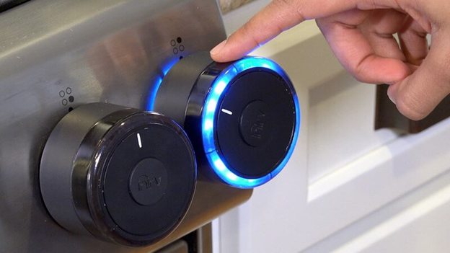

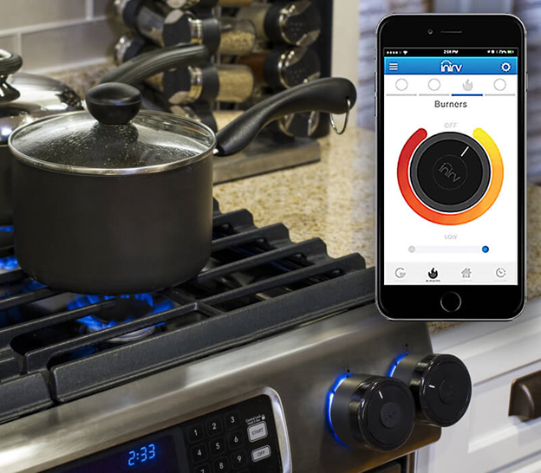

Inirv was on Shark Tank and did not receive a deal. Mark Cuban was concerned about intellectual property. Robert Herjavec offered $800,000 for 20% of the company, but Inirv countered causing Herjavec to retract his offer. Lori Greiner said that she loved the idea, but the product did not seemed finished at the time of the pitch. This gives us confidence in our product because we believe our product provides more features and use cases and there is interest in not only investors but our target market. As the world moves closer to a fully smart home we aim to take this head on and contribute with our product in this movement.

# Overall Architecture

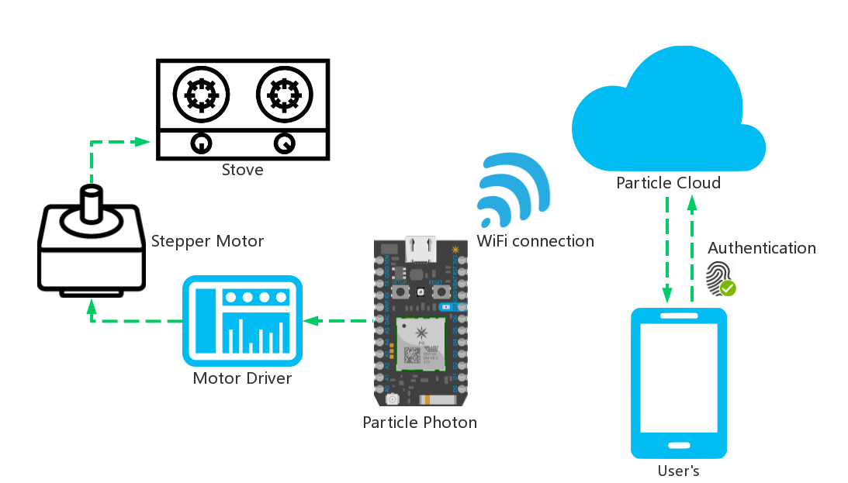

system architecture

There are four building blocks in our architecture:

1. Mechanical components: Stove, stepper motor and motor driver
2. Microcontroller: Particle Photon
3. Cloud service: Particle Cloud
4. User side: user’s smartphone

Main information flow: Users send commands to particle via Wi-Fi connection or cellular network, then particle cloud sends messages to particle photon via Wi-Fi connection, after interpreting instructions, particle sends signals to drivers and then driver drives the motor. In the other hands, photon sends values of variables to particle cloud and user subscribe this values from particle cloud.

## Detailed Modules’ Description

### (1) Mechanism structure: Stove, stepper motor and motor driver

This is the driving part to rotate the rotary knob of the stove (to adjust level/temperature).

1. Stepper Motor

“A stepper motor or step motor or stepping motor is a [brushless DC electric motor](https://en.wikipedia.org/wiki/Brushless_DC_electric_motor) that divides a full rotation into a number of equal steps.” [reference: <https://en.wikipedia.org/wiki/Stepper_motor>] There are several kind of stepper motor, and we go for the most common one - bipolar 4-lead Stepper Motor. We choose Nema 17 Stepper Motor for our prototype because it has bigger torque. Furthermore, with precision of 1.8 degree (which can be further divided by a motor driver), it is enough for common use. This motor takes four wires (two pair) as input: A, B, C and D. These four wires are all connected to the stepper motor driver.

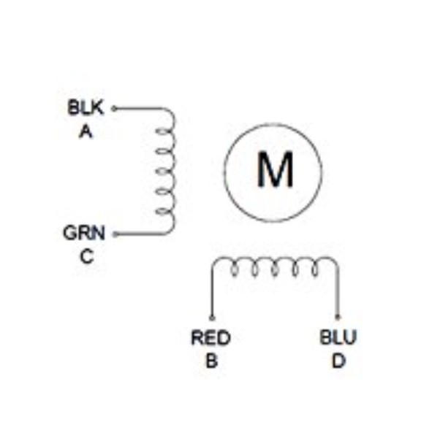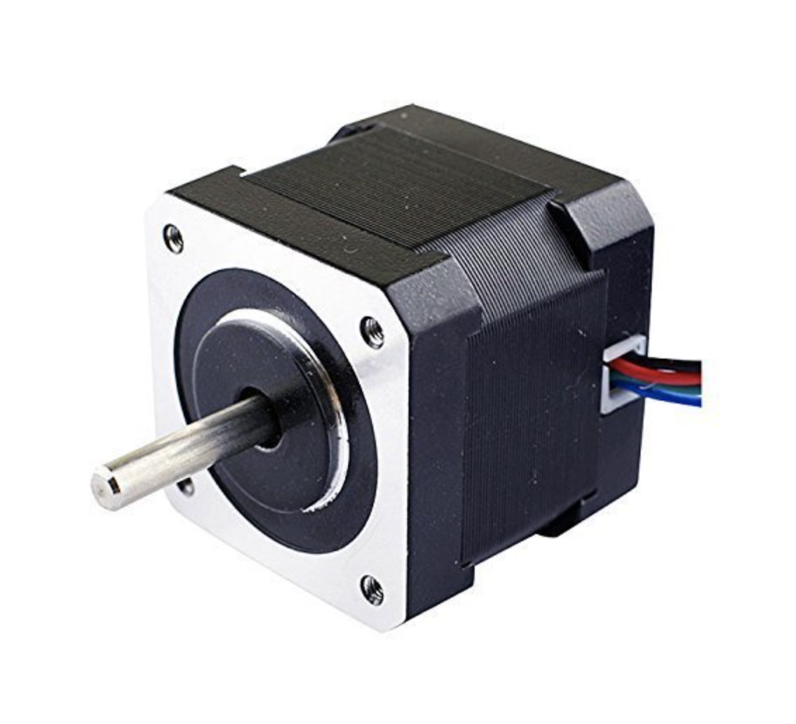

motor circuit diagram and picture

Specifications of our motor is in appendix.

[reference: <http://reprap.org/wiki/NEMA_17_Stepper_motor>]

2. Stepper Motor Driver

It is hard to control a stepper motor directly through a controller, instead it is better to use a stepper motor driver which provides an easier “API” for us to control the motor. We have a TB6600 stepper motor driver, it is compatible with Particle micro controller whose signal is 5V digital pulse and it is also compatible with Nema 17 stepper motor. This driver provides at most 32 division of the step(called micro step), so now we have precision of 1.8/32 = 0.056 degree.

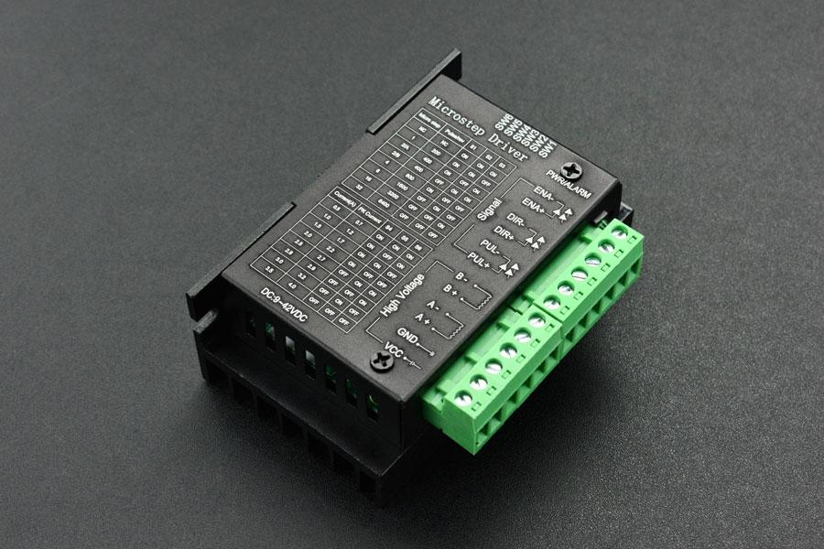

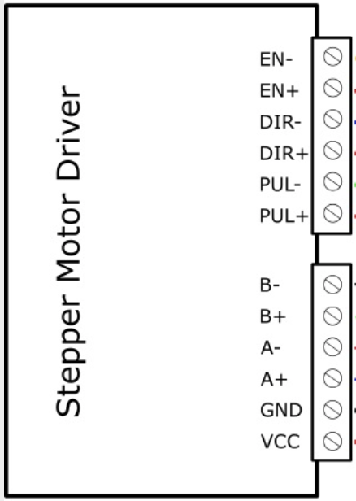

Specifications of our motor driver is in appendix. [reference: https://github.com/Arduinolibrary/TB6600_Stepper_Motor_Driver/raw/master/TB6600%20User%20Guide%20V1.2.pdf]

This driver takes 6 signals as input and connect to the motor with 4 wires, and of course, two wires for power supply. It needs 9~42V direct power supply, so we also have to buy an adapter.

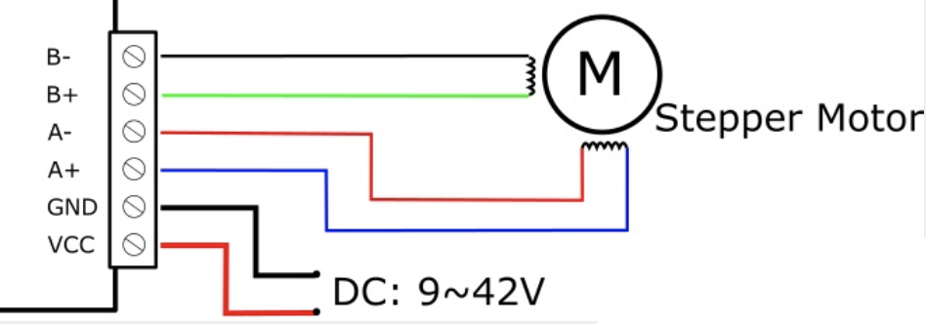

connection between stepper motor and driver

Connections to the stepper motor is quite simple, using the wire with correct color according to above circuit diagram is all. The tricky part is to control the signals. 3 signals (using common-cathode connection as example) are:

1. Enable (EN+, EN-): make motor in a free state (offline mode), it allows the motor to rotate manually. We usually can leave these two interfaces.
2. Direction (DIR+, DIR-): control the rotating direction of motor. keeping high voltage at DIR+ makes the motor rotate in clockwise, low voltage at DIR+ in anti-clockwise.
3. Pulse (PUL+, PUL-): a falling edge to PUL+ leads the motor to walk one (micro) step.

Concerns and possible solutions:

* In stepper motors, there is no feedback in its circuits to tell the actual rotation degree, so when applied torque is too big, there will be “step loss” which means the motor does not take action after some pulses. In other words, it might not rotate to the degree we asked for.

We have three solutions for this.

* Use servo motor instead of stepper motor. There are feedbacks in servo motor, so we can check the rotation with our expectations. Usually a servo motor is more expensive than a stepper motor.
* Design a degree detector like sliding register to detect how many degrees it actually goes.
* Use a stepper motor with larger torque to prevent step loss.

Since we have limited funds, we decide to combine 2 and 3 as our solution.

* More powerful motor needs stronger power supply, 5V is enough for a small motor, but we need 9V-42V for our large motor. Considering we usually have electricity-drive stove, this should be easily solved by an adapter.

### (2) Microcontroller: Particle Photon

This part is for receiving user’s commands via Wi-Fi and sending control signal to driver.

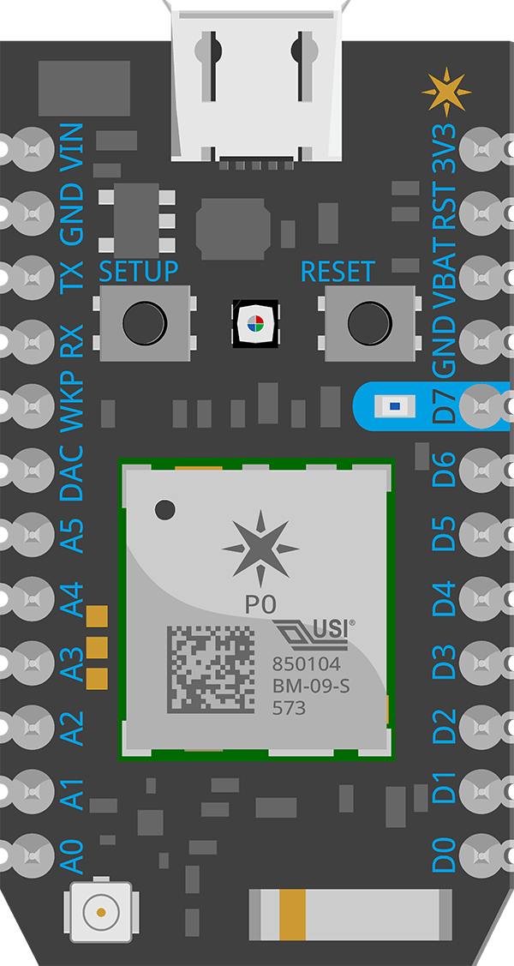

Particle Photon is a micro controller with Wi-Fi module, it can send both digital and analog signals and it can be powered by 5V direct power supply. We use common-cathode connection for connection between micro controller and driver, and use two digital output port for controlling direction and sending pulses.

Schedule function is also supported here, photon has clock inside so that it carries out plans when time is up.

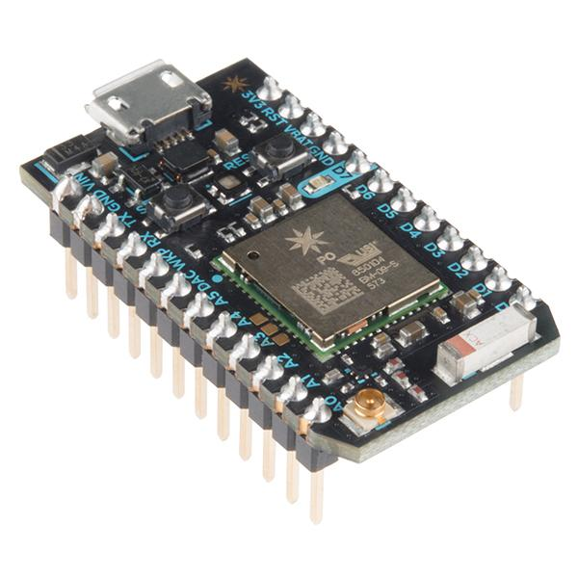

Particle Photon

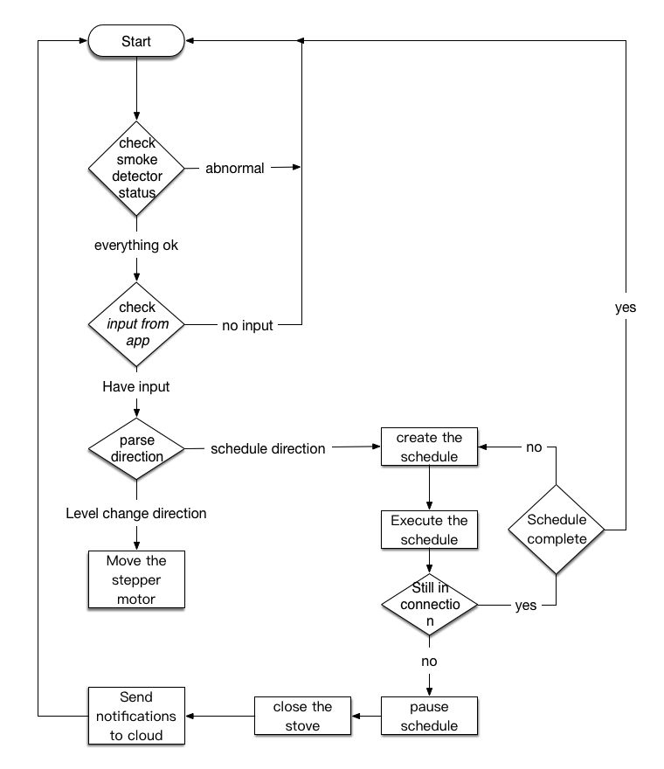

flow diagram in particle

### (3) Cloud service: Particle Cloud

Particle provides a Particle Cloud Service. After Photon connects to internet via Wifi, it then establishes its connection to the Particle cloud. There are four basic functions we want to use:

1. Remote control

By calling particle cloud API, particle cloud sends string to photon and activate a particular function specified in URI. Then we interpret this string(instruction) in photon and take actions.

1. Get a variable value from particle

Particle cloud can get value from photon and allow us to subscribe these values of photon.

1. Authentication

Particle cloud provides access token after user set up their photon and apply their security strategies in data transmission between particle cloud and photon. Security of data transmission between user and particle cloud will be ensured by access token and https.

1. Check online or offline

We check the connection status of photon by pinging photon (an API provided by particle cloud).

### (4) User side: user’s smartphone app

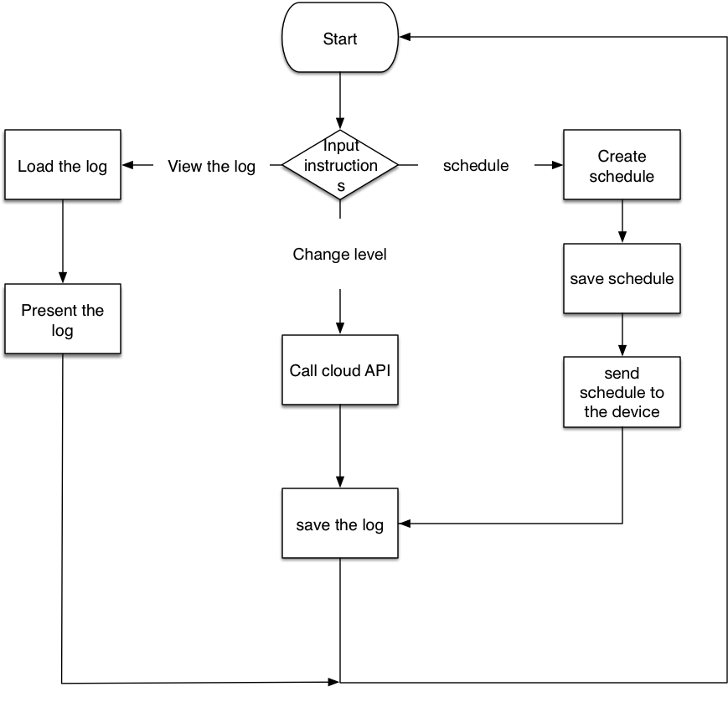

flow diagram of app

There are three basic functions we want to use:

1. Change the level of the stove remotely.

Users can use their applications to view the current level of the stove they owns and also change the level on their cellphones.

1. Make the schedule on their cellphones.

Users sometimes may want to make the schedule, such as level 5 for 5 minutes and then level 3 for 6 minutes. Users can make and save the schedule on the applications and then applications will send the whole schedule to the particle cloud.

1. Applications will also log users’ activities (eg: recipes and cooking events) for users to look up in the future.

# Wireframe Prototypes

The following wireframes are created by with lonic. Upon entering our stove controller app user will see the switch image on the primary tab interface. The direction of the image features the status of the stove.

## 1) Stove Tab

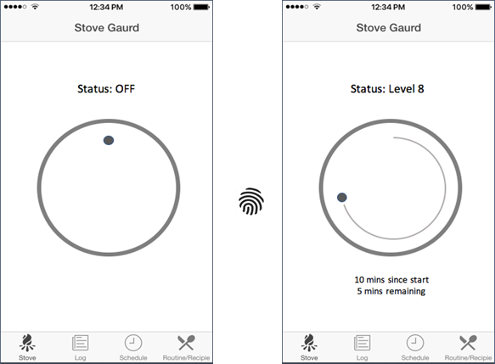

The stove is initially off. User can simply rotate the stove switch image to initiate a “turn on the stove” command. App will request authentication from user in the form of fingerID (for phones after 5s) or password predefined by the user. (More explanations regarding this authentication will be mentioned in the security section.) User can toggle the image to desired level and the corresponding switch rotation command will be sent to the physical device. The app also lists time elapsed during an ongoing cooking routine.

## 2) Schedule Tab

Some meals (like boiled eggs & ramen) can be prepared with single heat level setting, whereas some other meals require different temperatures at different timings. Users are allowed to define multiple cooking stages and the rest will all be taken care by the app. If people wants to edit an existing routine/recipe, the app will land on a similar interface below.

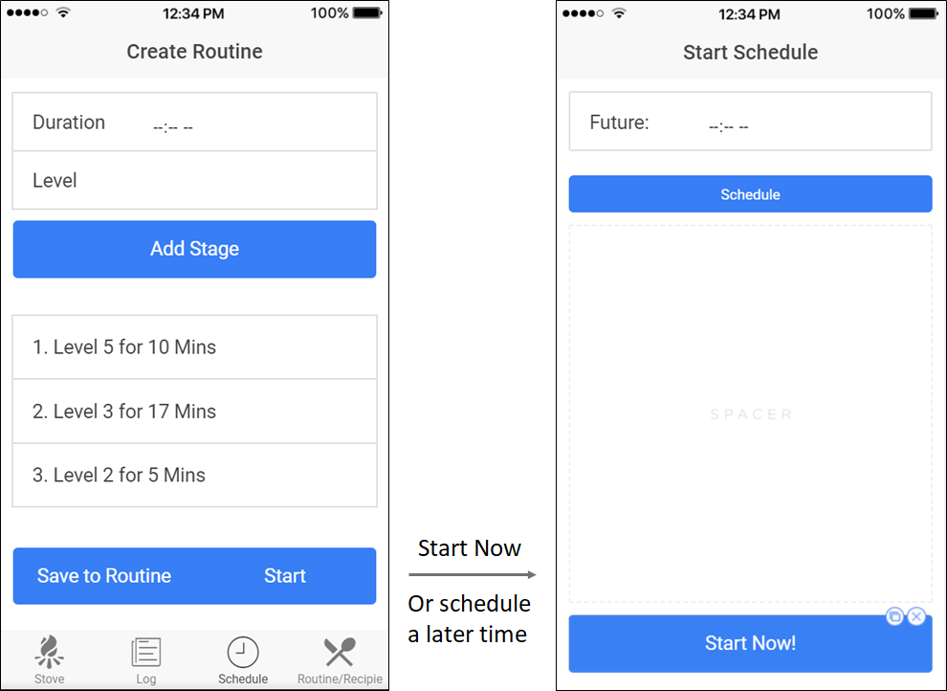

Users can also schedule cooking tasks to start in the future.

## 3) Recipe Tab

Stove Remote Controller app also allow users to store and load customized cooking routine. For example, user can view and select to carry out one of their existing recipe.

1. Hard Boiled Egg (8 minutes)
2. Soft Boiled Egg (4 minutes)
3. Tomato Soup (level 8 for 10 minutes + level 5 for 5 mins + level 1 for 20 mins)

Or define and save a new routine by clicking “Add” Button.

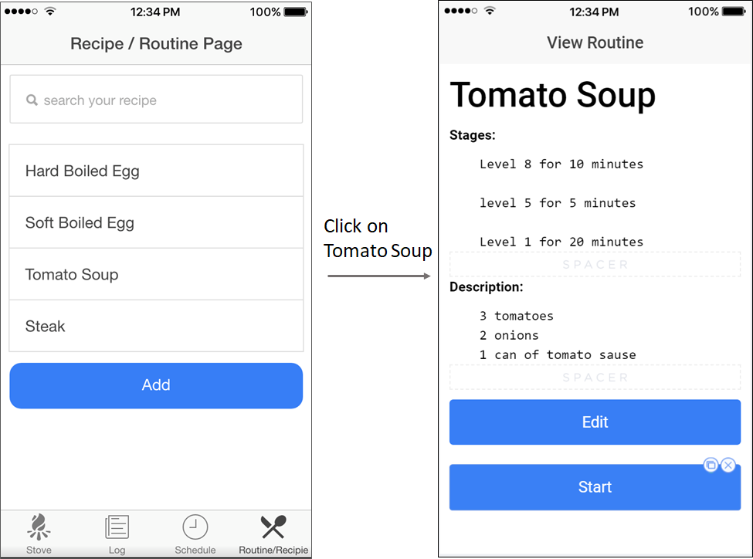

In the view routine page (on the right), users can see/edit the stages previously saved. Users can also enter notes such as ingredients and recipes under the description section.

Upon clicking start, the app will have the option to start now, or at a future timestamp.

## 4) Log Tab

Our app lists upcoming schedules and historical cooking events in the log tab.

1. Users can review and edit upcoming schedules.
2. Users can also review historical schedules & statistics, or repeat a past routine.

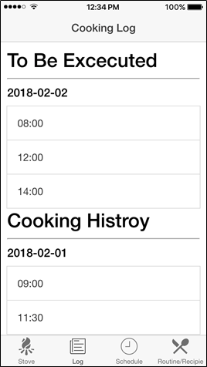

# Wireframe Prototypes Evaluation

There are four tabs on the bottom of our Stove Remote Controller App and they include our main functionalities: controlling the stove, recording user’s log, scheduling tasks, defining recipes. These four tabs remain on the screen for users to navigate through our app.

We carried out some user experience interviews after finishing our first wireframe prototype. We also took on some analysis regarding our UI designs, and we will state our refinement plan below.

## (1) Interview 1

**Demographics**

Sex: male

Age: 22

Highest degree earned: Bachelor of Engineering

Job: college student

**Interview Contents**

*Q: Which part of the product do you like most?*

I like the ‘routine/recipe’ tab. I think this is so convenient and useful for me, which save plenty of time when it comes to daily tasks such as boiling egg.

*Q: Which part of the product do you think that need some improvement?*

I don’t like the front page most. It feels so inconvenient and dumb for me to tap the screen in order to change the level. If I want to change the level from 1 to 7, I have to tap the screen 6 times to achieve my goal. It would be great if it is a dial so that I can simply swipe the dial and change the stove to my intended level.

Q: What is your biggest concern about our product?

Safely. I’m not sure what will happen to my stove when my smartphone lost connection to my device. I will be worried about the status about my stove.

## (2) Interview 2

**Demographics**

Sex: female

Age: 23

Highest degree earned: Bachelor of Engineering

Job: college student

**Interview Contents**

*Q: Which part of the product do you like the most?*

I like the design of the front page. It is beautiful and simple. I really love the icon of the stove.

*Q: Which part of the product do you think that needs some improvement?*

The ‘Log’ Page. It looks a little bit chaotic and confusing. I am not quite sure the purpose of keeping a cooking history. I don’t care about it, I don’t mind having it, but looks like it could be wasting memory.

*Q: What is your biggest concern about our product?*

Sometimes I want to cook meals that require heating on both sides. In such situation, I will have to stay next to the stove anyway.

## (3) Evaluation and Refinement

### 1) Stove Tab:

Our initial implementation requires tapping the stove image 7 times if users want to reach level 7. It would be much easier to mimic a dialing motion (with sliding or swapping gestures).

In the next iteration of development, we will replace the tapping gesture with smoother image rotation. Real-time status information will also be added under the dial image to indicate the cooking process (as we designed in wireframe)

### 2) Log Tab:

We wanted to use this page to show users’ cooking history, such as the timestamps and stages carried out by users in the past. But according to our survey feedbacks and internal evaluations, we think this tab should no longer exist on main screen because not many people care about reviewing past cooking events. However, users do still expect to see what is scheduled ahead.

We will lower the priority of this cooking history functionality. One possibility might be transferring the history to the scheduling tab and only limit the data collection to the past 24 hours.

### 3) Schedule Tab & Routine Tab

We received positive comments for these two page as most of the functionalities are under users’ expectations. Users can set a schedule by choosing a future start time as well as saving their own customized recipe, which is convenient in general sense as users can repeat their old routines.

We will not be making much changes in these two tabs in terms of the UI control-flow.

A common problem existing in all the pages are GUIs being way too simple and someone even say the word ‘ugly’. Our team have minimum experience on graphics design and our primary attention was to improve operation logistics as much as possible. At this stage we have pretty good functionality and usability but aesthetically unappealing.

# What We Have Implemented

Overall, we created an iOS application and finished the implementation of our stove switch interface (prototype version). From the phone app, we can control the stepper motor remotely to a specific degree (currently we divide the cycle into uniform 16 parts (360/16 = 22.5 degree)) by rotating a dial image button. More specifically, we are able to control the rotation direction and levels (multiples of 22.5 degrees) via our iOS application.

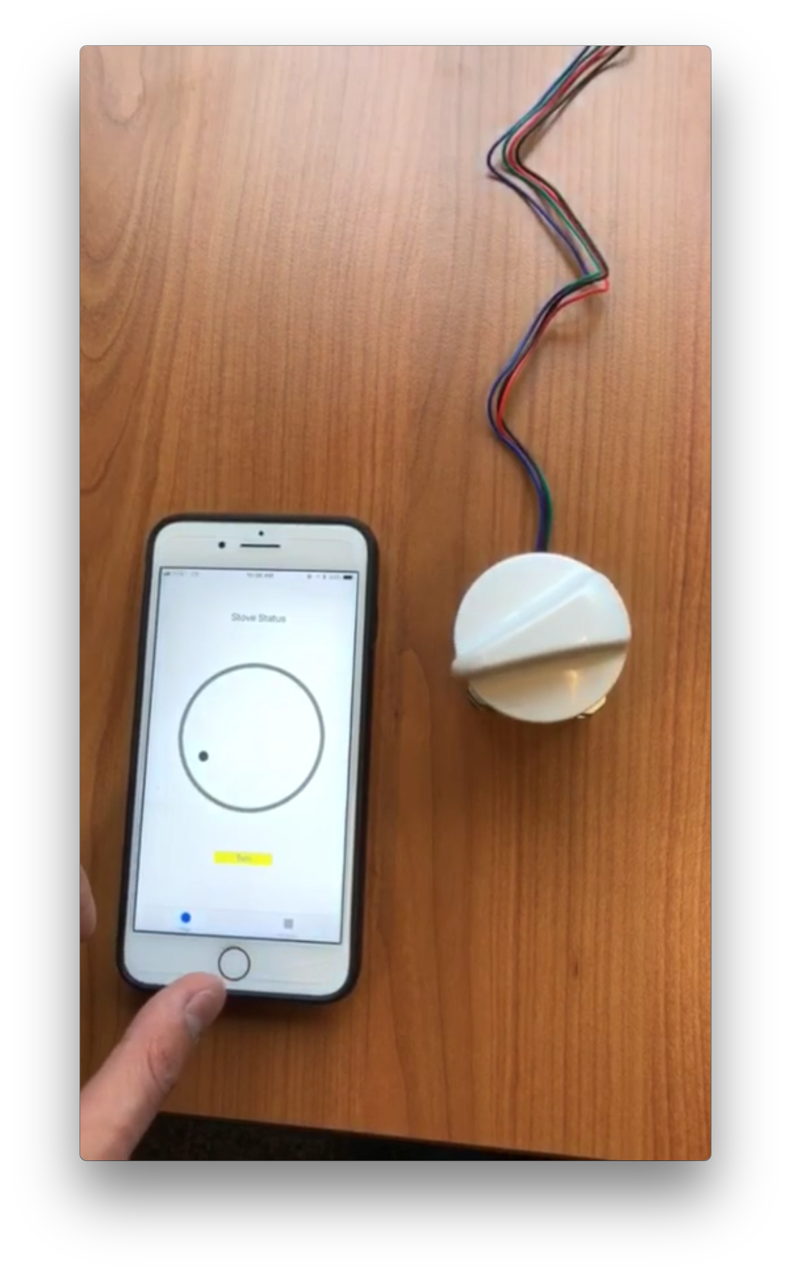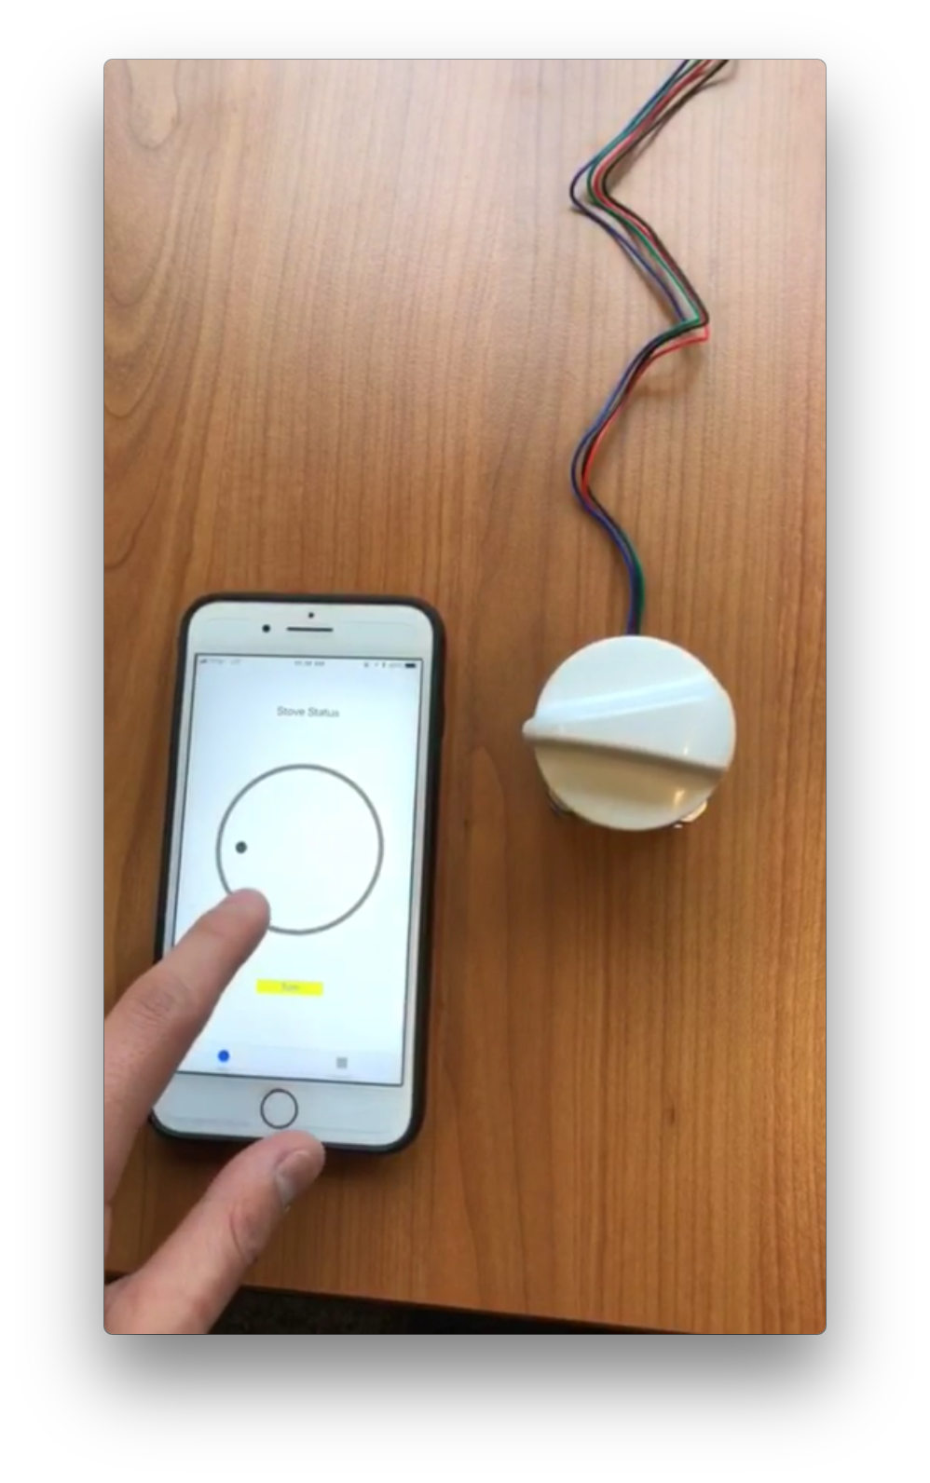

first prototype at poster session

## (1) Software

Software wise, we have implemented two tabs now, with the MVP feature being the “stove” tab mentioned above. Now it allows user to change direction by clicking “Turn” button and adjust the level by dialing and change between tabs.

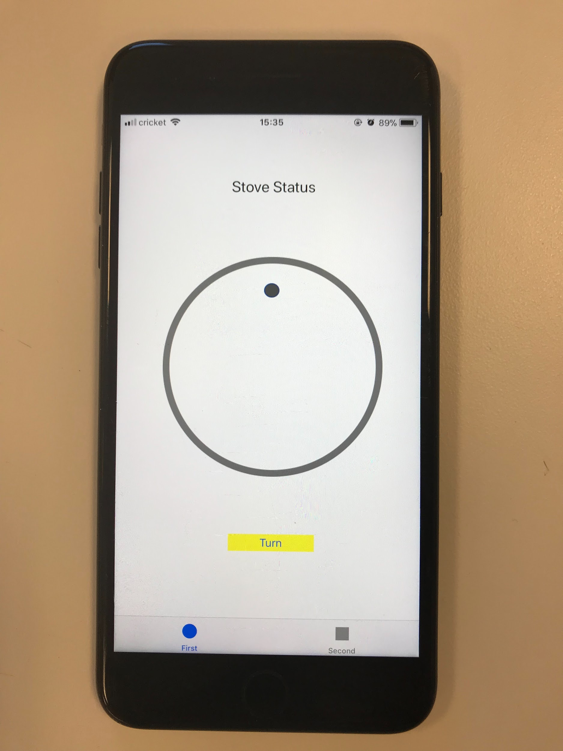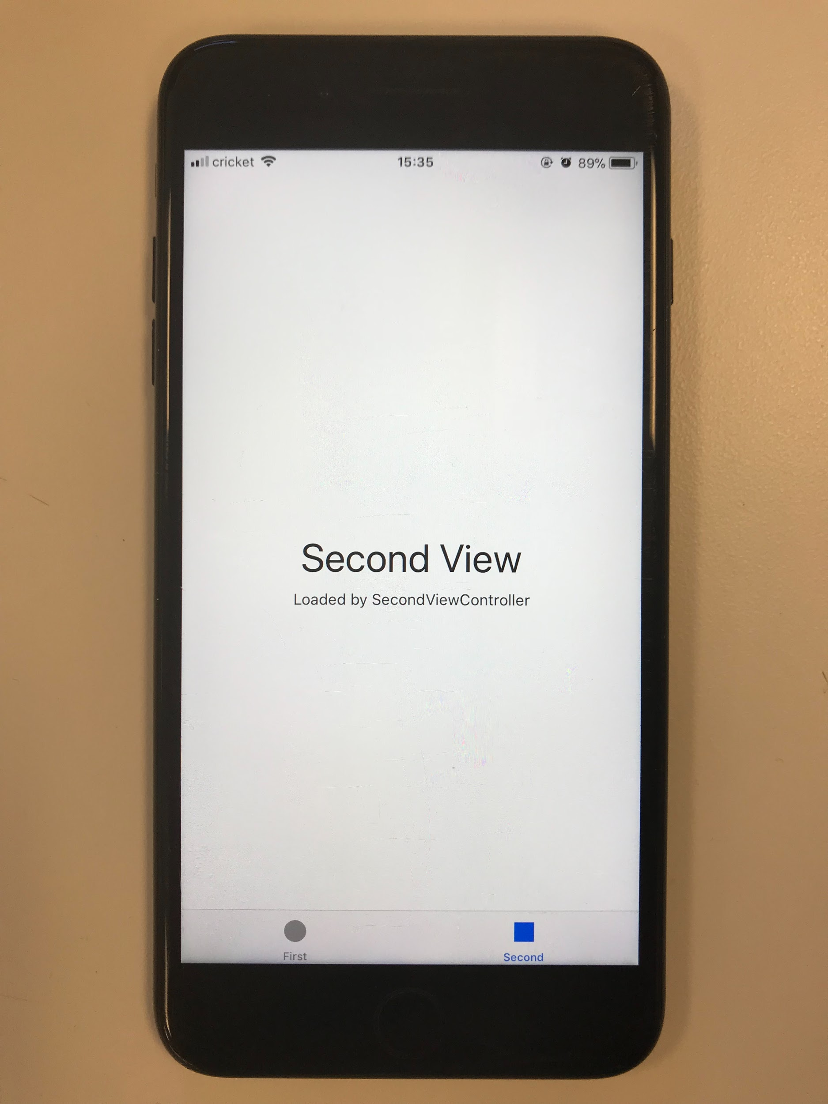

screenshots of our first app prototype

At backend, we setup the following two endpoints on the particle cloud, which can be used directly by our app via restful requests:

|  |  |  |  |
| --- | --- | --- | --- |
|  | TYPE | Endpoint | Argument |
| Rotate  (360/16 degrees) | POST | https://api.particle.io/v1/devices/<device-id>/pulse?access_token=<access-token> | pulse |
| Change rotation direction | POST | https://api.particle.io/v1/devices/<device-id>/direction?access_token=<access-token>" | clockwise/anti_clockwise |

**<device token>**: unique for each hardware device, which is used as an identifier in the particle cloud for the server to send back and forth communication with each device.

**<access token>**: when user first set up the device with our app, an access token will be generated which provides secure access to particle cloud’s APIs.

## (2) Hardware

In the hardware side, we figured out and finished all connections amongst photon, stepper motor and motor driver. Now the best precision of motor we provide is 1.8/4 = 0.45 degree and the frequency of sending pulses is 100Hz now. In particle, we now provide two functions inside particle:

int pulseToggle(String command)

int dirToggle(String command)

In pulseToggle(), if command equals to “pulse”, particle will send falling edge every 10ms to PUL+ port of driver to drive motor for 50 times, as one step is 0.45 degree, so one call leads to 0.45 * 50 = 22.5 degree rotation.

In dirToggle(), if command equals to “anti_clockwise”, particle sends low voltage signal to DIR+, driver will drive the motor in anti-clockwise in following pulses. Otherwise, if the command requests to “clockwise”, particle sends high voltage signal to DIR+, driver will drive the motor in clockwise in following pulses. And we also program a LED to blink as sending out pulses signals for debugging.

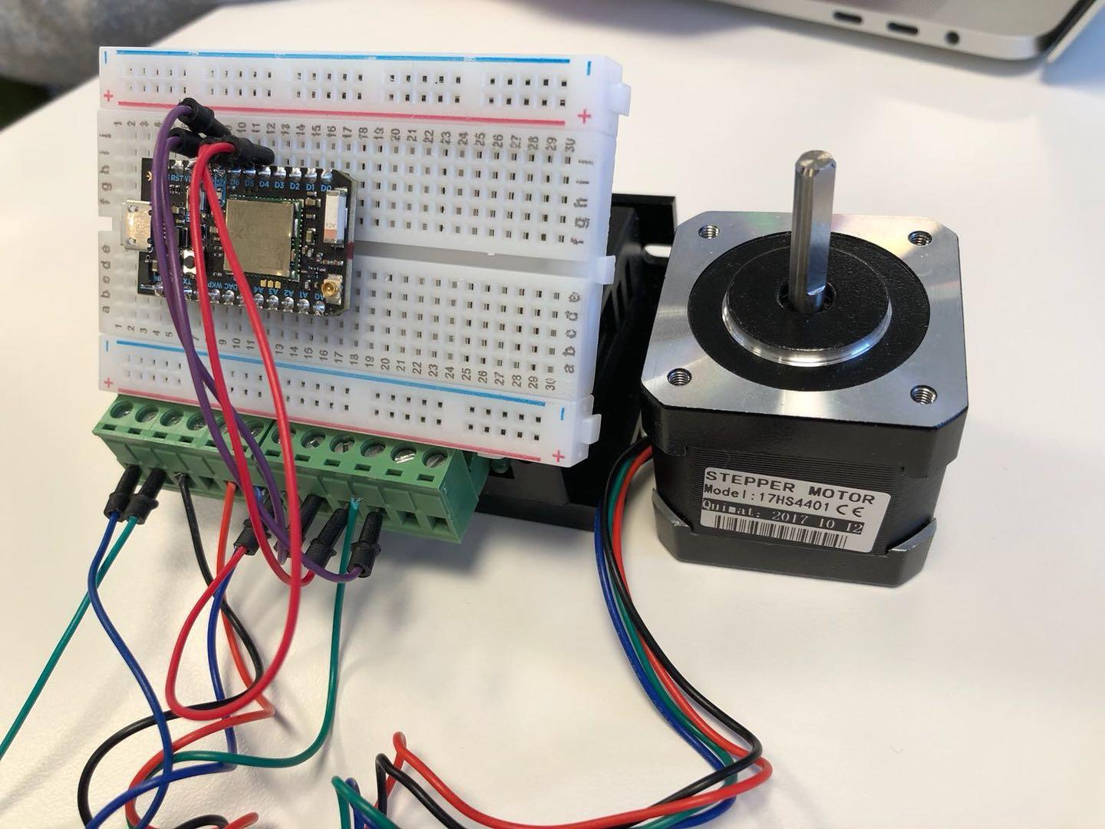

Mechanism and controller part

# Security and Privacy Evaluation

## (1) Physical Safety

Our team members carried out a vigorous debate around whether it would be safe to allow users remotely turning on the stove. There are possibilities that users could forget to turn it off, or having their kids curiously playing with all the buttons. For the former problem, we set a threshold of running time and plan to add smoke detector or fire detector to prevent it from burning the house. As for the latter one, we use fingerprint authentication to avoid app being operated unintentionally by users or by kids or pets.

## (2) Information Security

### 1. Data Transmission Security

Security between photon and particle cloud is ensured by Particle. They design their own security strategies and communication protocol.

Security between particle cloud and user’s phone is for ensuring user’ device (photon) can be accessed only by the two parties. This is ensured by a two-step strategy.

When user get their device at the very beginning, they need to set up WiFi connection, during this, user will connect their phone to photon’s WiFi and then connect photon to their own WiFi. After setting up, user will get an access token from particle cloud. Then, any API calls are through HTTPS and require the access token.

This means that only the user who is physically around the device can set up device, and later access token is transmit via HTTPS connection. So the risk of access token being intercepted lies in HTTPS connection considering that physical access is quite safe. After getting access token, upcoming api calls are also via HTTPS connection. In conclusion, if HTTPS connection is safe, data transmission between particle cloud and user’s phone is safe. So, users do not need to worry about other people controlling their stove.

We have considered about replay attack because it could be very dangerous if attacker use replay attack to turn on your stove. As described above, we use HTTPS to make API calls, and HTTPS is NOT subject to replay attack, so attacker cannot apply replay attack.

Access token is 320 bits long, it is computationally hard to break the key, so it is also impossible to guess the token.

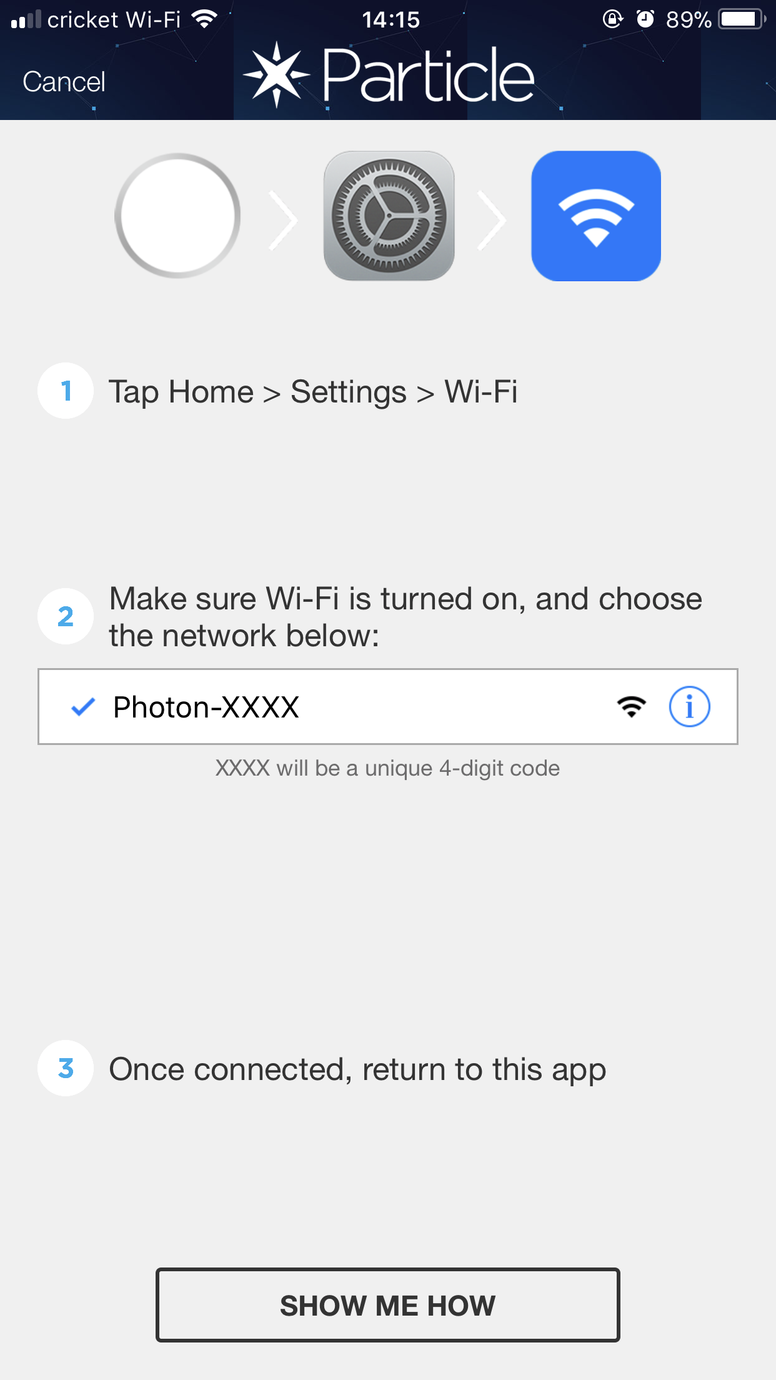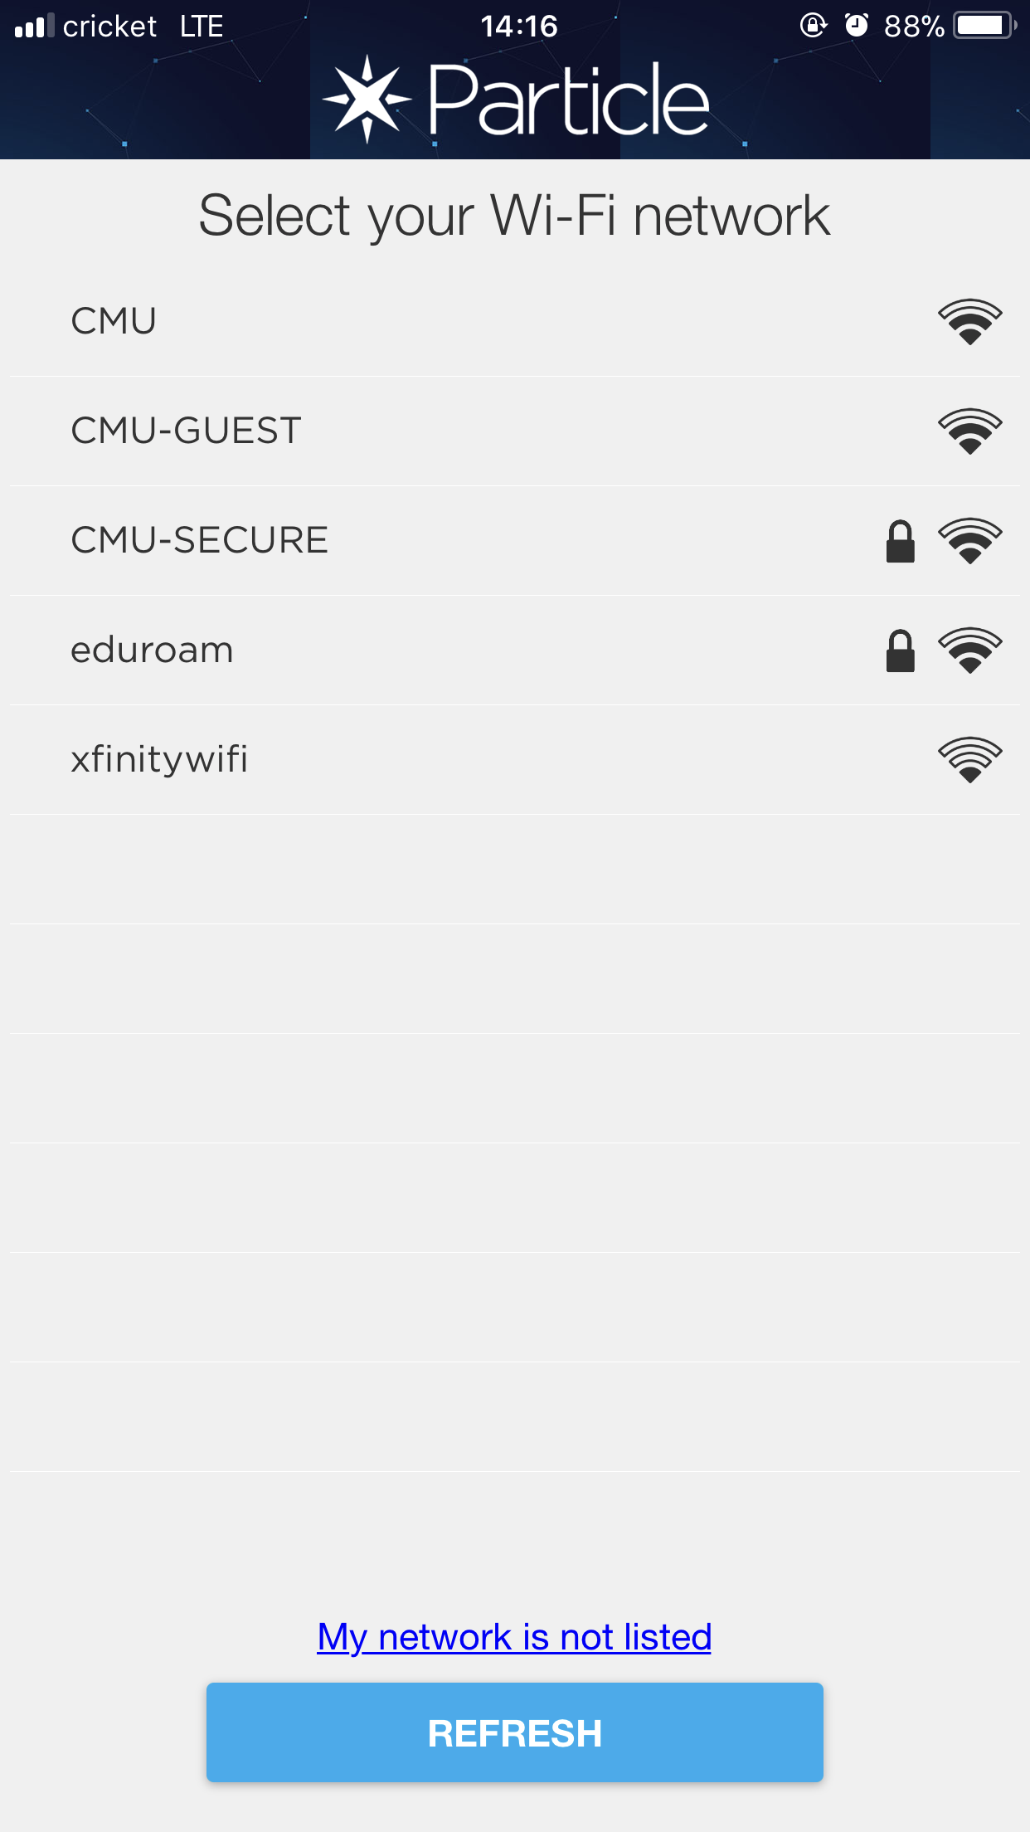

set up interface

### 2. Privacy

Users probably do not want other people to know their cooking habits or even their schedules. So we only store logs at local smartphone and it is protected by fingerprint authentication. In addition, decrypting HTTPS messages are computationally impossible, it is infeasible to know users’ schedules by break HTTPS messages encryption as mentioned above.

# Challenges, Limitation and Possible Solutions

1. We cannot handle the meals that requires to be cooked with human actions. For example: flipping, stirring and seasoning.

This is limited by the design and principal of our devices as we cannot flip the meal automatically. Users will still need to be physically present if they want cook the dish the way they want it to be.

1. The prototype we are building now is still quite bulky. If we leave the design as the way it is, customers will find it hard to install the unit on their existing stove because it takes too much space around the area.
   1. We are in the process of ruling out parts and pieces that are deductible (in terms of physical mass) and encapsulate all the nuts and bolts in a nicer looking “black box”.
   2. We can also pitch our product to manufacturers, and have them embed our controller in merchandised stove products. This way all the hardware components can hide inside.

# 

# Future Work

To completely implementing the function of our project, we plan to have a continuous iteration of product and add more features both to our device and application.

## (1) Some Other use cases

**Use case 1:**

Users may find it a little bit scary to leave the stove on and just control the stove with their cellphones.

Although it is actually very safe to use our product to control the stove and our device will automatically shut down the stove when disconnected to the cellphone or leave the stove on for too long time. People are afraid of trying new things and will be skeptical when they are not actually seeing what is happening right now with their own eyes.

To ease our customers’ concern, we are planning to add the camera and smoke detector to our device. When our device detect that there are unusual amount of smoke around the stove, it will first shut down the stove automatically and then send notifications to the user’s application to remind them of this accident. In addition, the device will have a built-in camera so that users can always check the status of their meals even when they are in their bedroom.

**Use case 2:**

Voice control with Alexa.

It might be impractical for users to carry a phone at home (especially while doing chores), but we foresee an increasing installation of voice based devices like Alexa in ordinary household.

Enabling Alexa skill for our stove hardware device would allow users to ask simple commands like “Turn off the stove!”, or “How long/when did the cooking start?” Which could further free users from even holding a phone to control the stove remotely.

## (2) Schedule of future work

|  |  |
| --- | --- |
| 2018.03.02 - 2018.03.14 | Design and run another survey about our existing product and additional features that will be added to the product. |
| 2018.03.14 - 2018.03.28 | Start to choose the smoke detector and camera that are compatible with our product. |
| 2018.03.28 - 2018.04.07 | Try to mount the detector and camera on our device and debug the hardware |
| 2018.04.07 - 2018.04.14 | Design the application UI and write code of the newly added features. |
| 2018.04.14 - 2018.04.28 | Review the code and run tests against our application. Try to assemble our product in a compact manner. |
| 2018.04.28 - 2018.05.02 | Work on the final report of this proj  ‘ect and archive all the documentations and source code. |

# Job Break Down

Paul Park:

1. Create the customer survey
2. Gather responses for the survey and analyze responses
3. Business model (B2C, B2B)
4. Competitor analysis
5. Revenue model
6. Poster design

Rongpeng Zheng:

1. Design the survey
2. Design the User Interface
3. Choosing models of motor and driver
4. Implement and test all hardware devices
5. Program particle photon, provide API
6. Work on the poster

Sihan You:

1. Design the survey
2. Design the User Interface
3. Design the API
4. IOS development with swift 4 (entry point, stove image rotations)
5. Work on the design of the poster

Zhexi Liu:

1. Design wireframes and image assets
2. Design restful endpoints
3. Design the survey
4. IOS development with swift 4 (controller views, communications between Particle Cloud and phone app via Restful API requests)
5. Work on the design of the poster

# GitHub repo

https://github.com/cozybed/08781-remote_stove

# Reference

*1.“Stepper motor.” Wikipedia, Wikimedia Foundation, 28 Feb. 2018,* <https://en.wikipedia.org/wiki/Stepper_motor>*.*

*2. Arduionolibrary. “TB6600 Stepper Motor Driver User Guide.” TB6600_Stepper_Motor_Driver/TB6600 User Guide V1.2.Pdf at master · Arduinolibrary/TB6600_Stepper_Motor_Driver, 14 Oct. 2016,* [https://github.com/Arduinolibrary/TB6600_Stepper_Motor_Driver/blob/master/TB6600%20User%20Guide%20V1.2.pdf](https://github.com/Arduinolibrary/TB6600_Stepper_Motor_Driver/blob/master/TB6600%2520User%2520Guide%2520V1.2.pdf)*.*

*3. “NEMA 17 Stepper motor.” NEMA 17 Stepper motor - RepRapWiki,* <http://reprap.org/wiki/NEMA_17_Stepper_motor>*.*

*4. “U.S. fire statistics.” U.S. Fire Administration, 18 Dec. 2017,* [www.usfa.fema.gov/data/statistics/#causesNR](http://www.usfa.fema.gov/data/statistics/%23causesNR)

*5. “Fire Estimate Summary-Residential Building Fire Trends (2006-2015)” U.S. Fire Administration, May 2017*

<https://www.usfa.fema.gov/downloads/pdf/statistics/res_bldg_fire_estimates.pdf>

# Appendix

## Poster

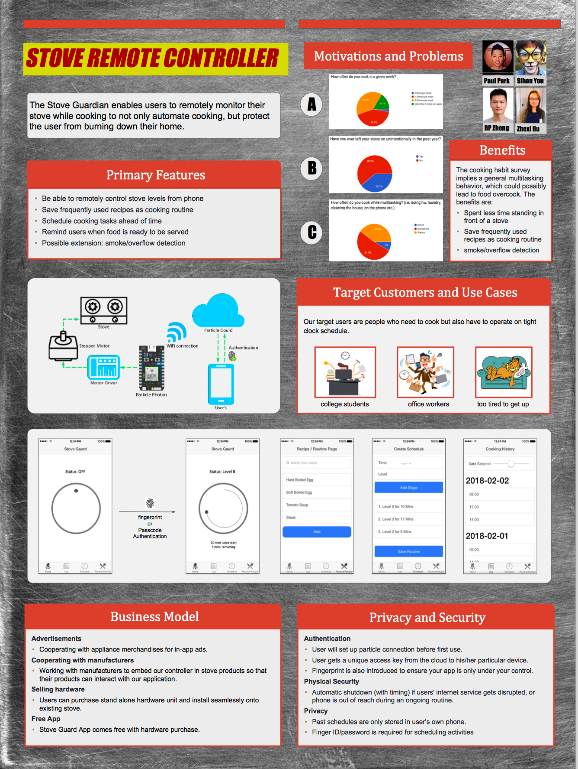

## Survey Questions

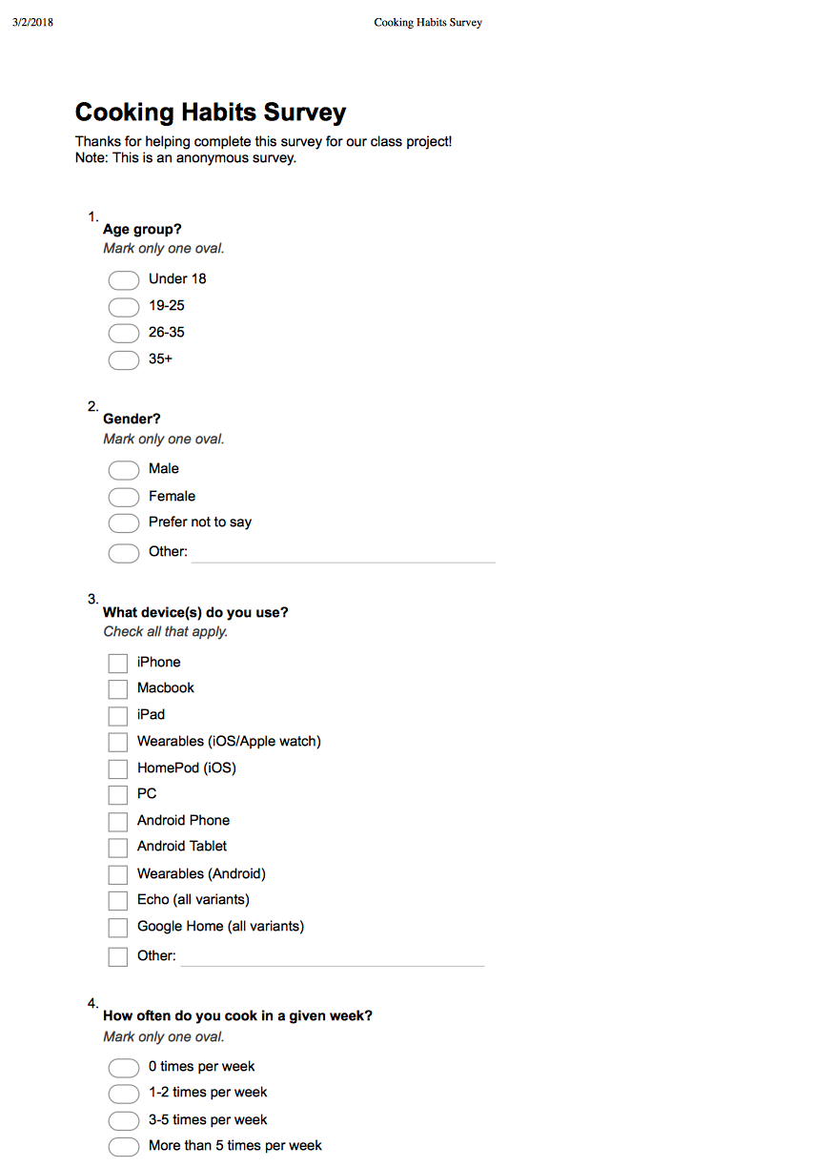

## image66.png

## Survey Response Statistics

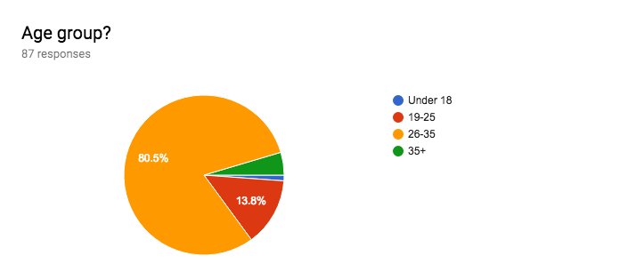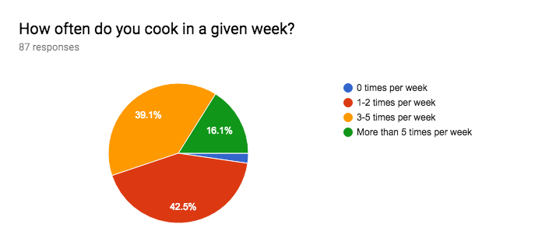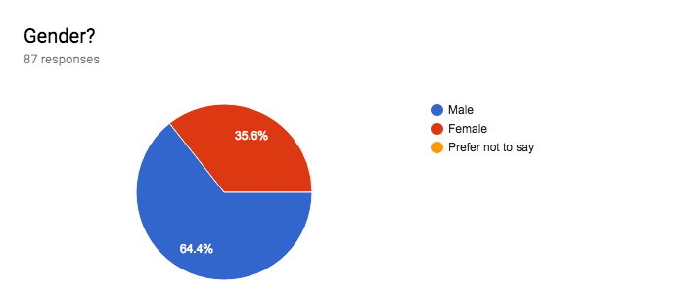

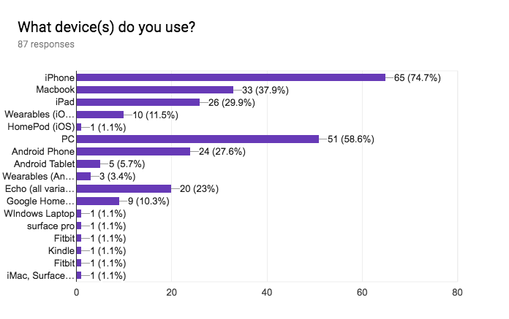

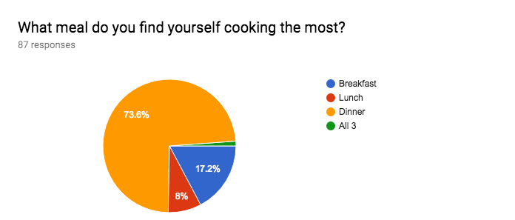

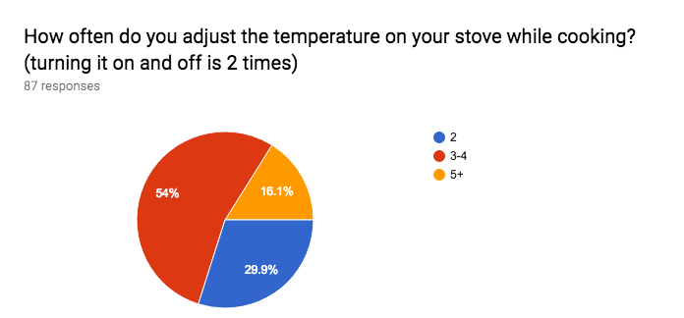

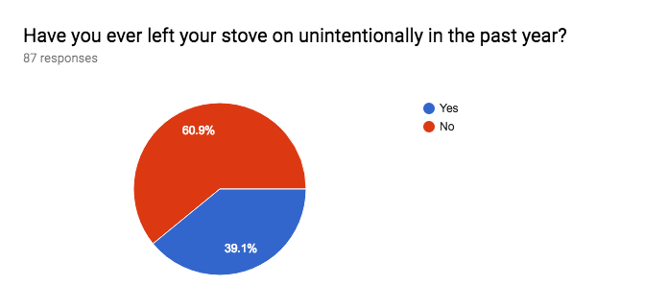

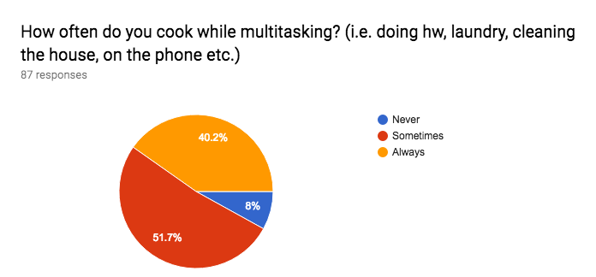

## Original Response

Fields From left to right:

Age

Gender

Cooking Frequency

meal cooking the most

Temperature Adjusting Frequency

Ever leave stove on unintentionally this year

Frequency of Multitasking while cooking

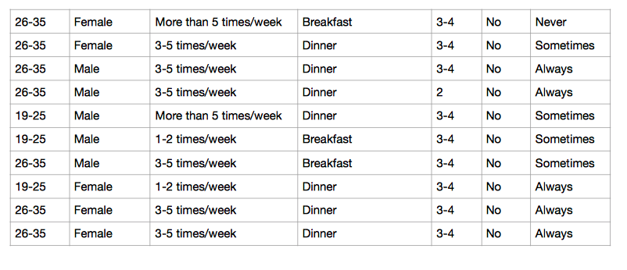

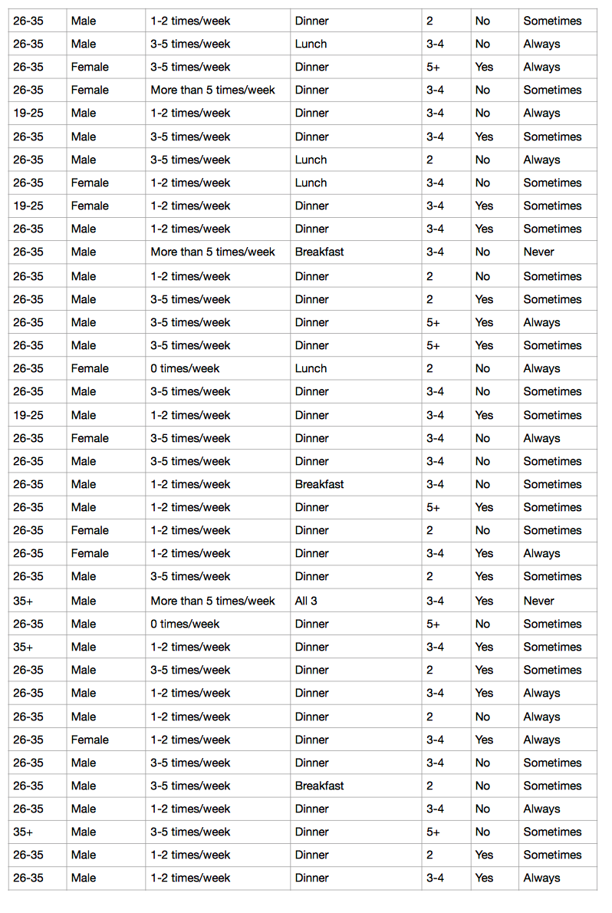

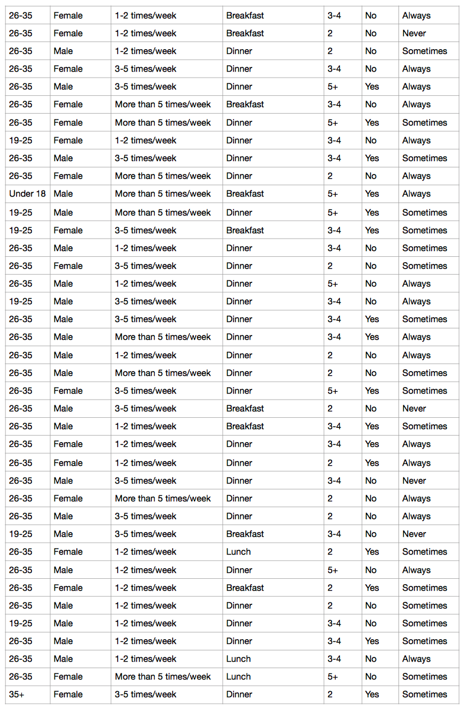

## Hardware Specifications

**Nema 17 Stepper Motor Specification:**  
* Motor Type: Bipolar Stepper  
* Step Angle: 1.8 deg.   
* Holding Torque: 40N*cm(56.6oz.in)  
* Rated Current/phase: 1.7A  
* Phase Resistance: 1.5ohms  
* Inductance: 3.0mH+/-20%(1KHz)   
* Frame Size: 41 x 41mm  
* Body Length: 48mm  
* Shaft Diameter: 5mm  
* Shaft Length: 24mm  
* D-cut Length: 15mm  
* Number of Leads: 4  
* Lead Length: 1m with connector  
* Weight: 280g

**TB6600 Motor driver Specification**

* Input Current: 0~5A

* Output Current: 0.5-4.0A

* Control Signal: 3.3~24V

* Power (MAX): 160W

* Micro Step: 1, 2/A, 2/B, 4, 8, 16, 32

* Temperature: -10～45℃

* Humidity: No Condensation

* Dimension: 96*56*33 mm/ 3.78*2.2*1.3 inches

* Weight: 0.2 kg